**Project Design Phase Technology Stack (Architecture & Stack)**

|  |  |
| --- | --- |
| **TEAM ID** | **PNT2022TMID50586** |
| **PROJECT NAME** | Real-Time River Water Quality  Monitoring and Controlling System |

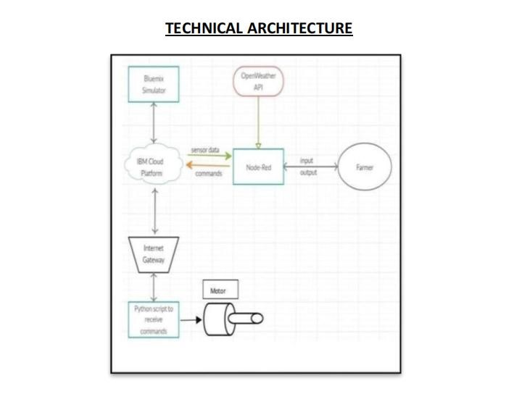

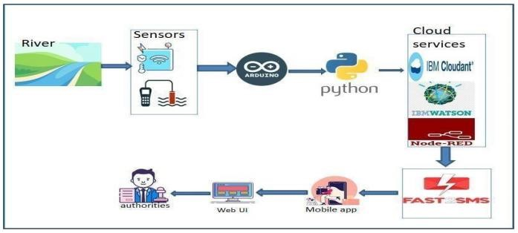

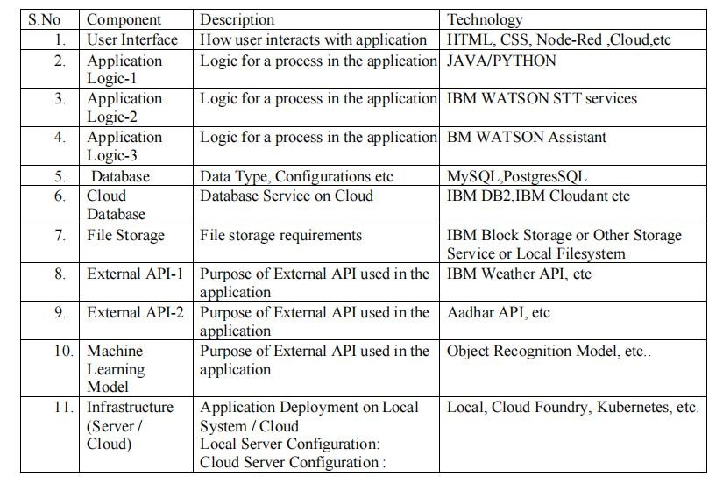**Table-1 : Components & Technologies:**

